|  |  |
| --- | --- |
| http://compsci.appstate.edu/sites/compsci.appstate.edu/files/imagecache/slideshow/slideshow/ASU_compsci_logo.png  **The Research Experience for Teachers Program** | https://encrypted-tbn3.gstatic.com/images?q=tbn:ANd9GcQGzOU-XT8XZWIBUwiPs2jjgixLO3CvrEyNq90lu1dbXJ0BQume  [**http://www.cs.appstate.edu/ret**](http://www.cs.appstate.edu/ret) |

C C:\Users\gordona\Pictures\penny.jpg in CC:\Users\gordona\Pictures\penny.jpgunter with Makey Makey

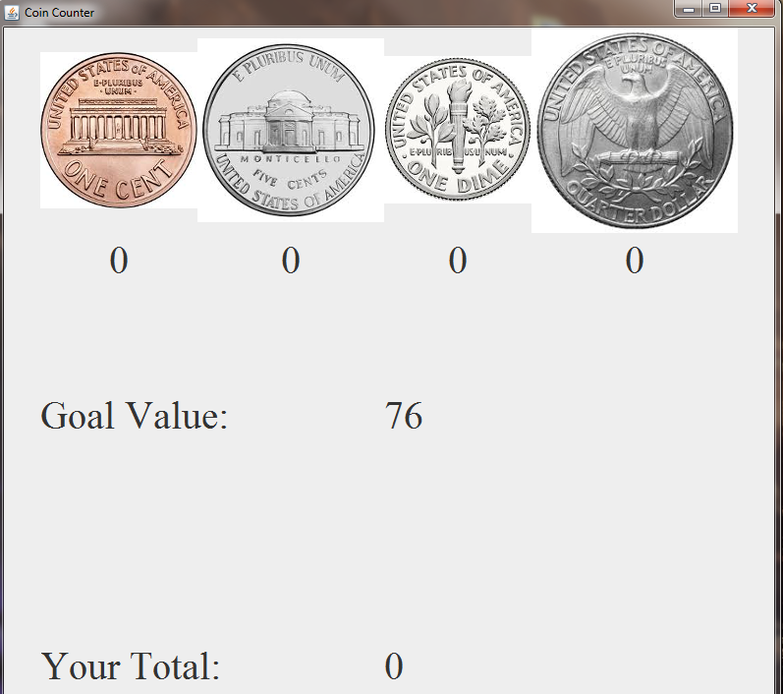

**Objective**: Practice basic math and computing concepts with currency counting. Obtain a basic understanding of Discrete math concepts “combinations” and “permutations”.

**Questions**:

1. What are the fewest amounts of coins that can be used to reach a given value?
2. What are all of the valid combinations and permutations of coins?
3. What values can only be reached using certain coins?

**Preparation**: The following steps will setup the Makey Makey to work on your computer as well as enable it to correctly control the Coin Counter program.

1. Extract Coin Counter Activity folder to desktop
2. Open Arduino-1.0.5–r2 -> arduino.exe
3. In the Arduino IDE toolbar, select File -> Open -> Desktop -> Coin Counter Activity -> makey_makey_1_4_1 -> makey_makey_1_4_1.ino
4. Arduino will open a new Arduino window with two tabs called makey_makey_1_4_1 and settings.h
5. Plug in the MaKey MaKey
6. Open device manager (You can search for it by clicking the Windows Start button)
7. Under ‘Other Devices’ Arduino Leonardo will appear.
8. Right click it -> update drivers -> click Browse -> Coin Counter Activity -> Arduino-1.0.5 – r2 -> drivers -> click open -> click install
9. Go to the Arduino IDE toolbar, select Tools -> Board -> Arduino Leonardo (see Figure 1)

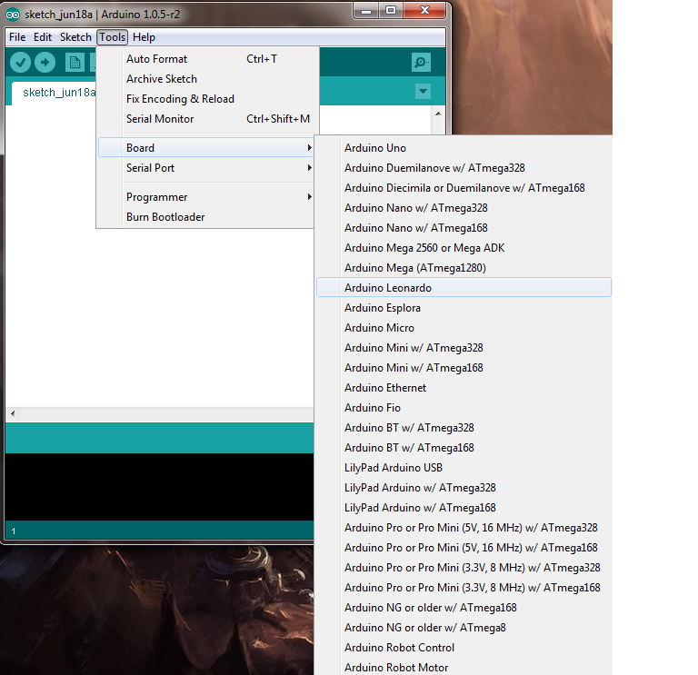

Figure 1: Configuring Arduino IDE for Makey Makey

1. Then select Tools -> Serial Port -> (Click the COM port that corresponds with the port number beside Arduino Leonardo in device manager.)
2. Click the upload button in Arduino and immediately go back to device manager and watch for MaKey MaKey to appear under the ‘Ports’ section.
3. When it appears right click it as fast as possible and select properties (Note: if you don’t right click quickly enough you will need to unplug the MaKey MaKey)
4. Switch to Driver tab. Select Update Driver -> Browse my computer for driver software -> click Browse -> Coin Counter Activity -> driver. Then click Next
5. Now go back into Arduino and change the serial port (Under Tools) to match the new COM port number under ‘Ports’ in Device Manager.
6. Click the upload button in the Arduino IDE. (You should wait for the upload to complete. There may be upload errors, if so attempt next step) The MaKey Makey setup should now be complete.
7. Double click the Coin Counter.jar file in Coin Counter Activity folder which should be on the desktop. This will run the Coin Counter program.

**Controlling Coin Counter**

The goal of the game is to reach the generated value with the fewest amounts of coins possible. Select the coin values you want to use by pressing the corresponding Makey Makey buttons (see Figure 2). If you make a mistake the game will prompt for a restart (Figure 3). If you are successful you will be asked if you want to play again (Figure 4).

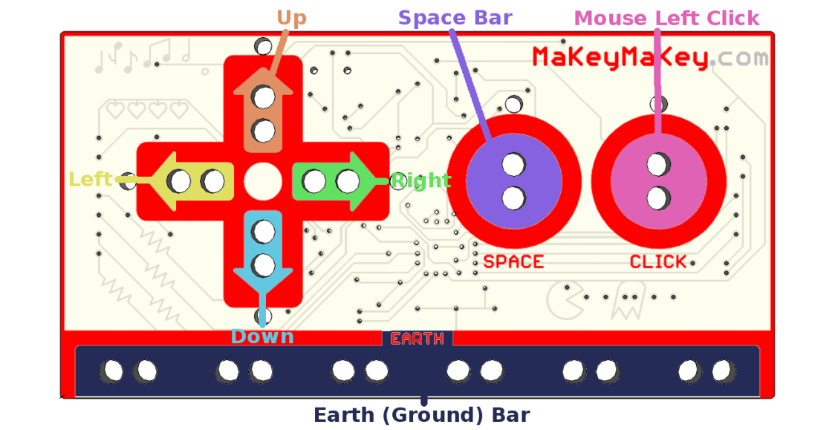

Figure 2: Diagram of Makey Makey Hardware

1. Left Arrow Key increases the penny value.
2. Down Arrow Key increases the nickel value.
3. Right Arrow Key increases the dime value.
4. Up Arrow Key increases the quarter value.
5. Click button enters a new game.

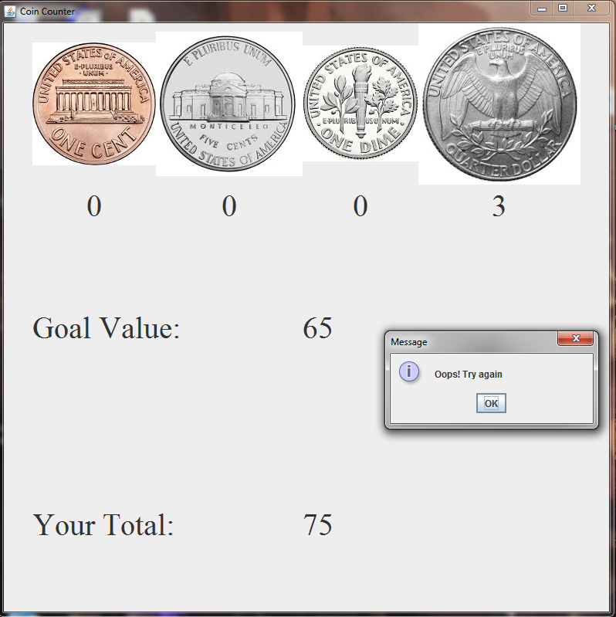

Figure 3: Fail Screen

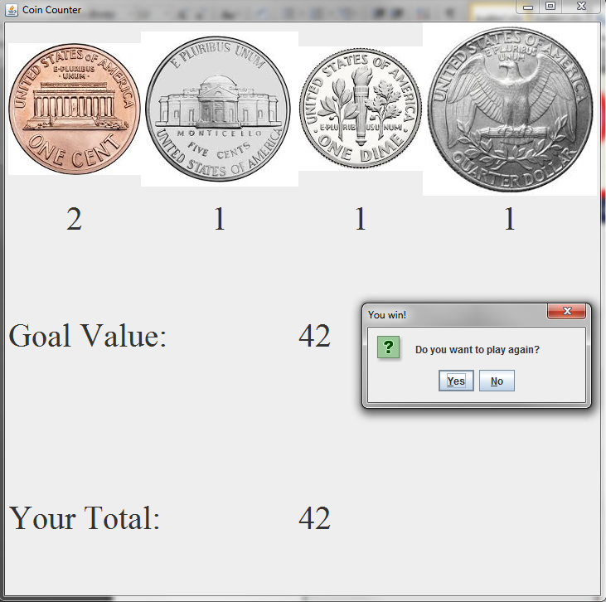

Figure 4: Victory Screen